Aquaculture on Vancouver Island
Prepared for the Vancouver Island Economic Alliance and Foreign Trade Zone Vancouver Island by
Bill Collins and John McCannel
February, 2019

Sustainable Aquaculture Business Case

Product Overview
Aquaculture on Vancouver Island consists of the cultivation of finfish, shell fish and the harvesting of aquatic plants.
Atlantic Salmon is the prime finfish farmed in BC while Chinook, Coho and Sockeye are also cultivated. In addition to salmon species, Steelhead Trout, Sablefish, Sturgeon and Tilapia are also farmed. Fish are harvested and processed locally and made available as fresh, frozen and canned products destined for the consumer, both domestic and international. The process of fish farming involves raring of seed stock in land based hatcheries in tanks. At the appropriate stage of maturity, fish are transferred to a closed containment system until such time as they are old enough to be moved to larger pens in open water settings from where they are eventually harvested. The fish are usually transported to processing facilities by truck and boat. In many cases fish pens are in close proximity to land based processing facilities.
Shellfish aquaculture delivers products such as oysters, clams (including Geoducks), mussels and scallops both domestically and for export. Shellfish products are delivered as fresh, frozen or canned. Portions of the fish are prepared for secondary processing. Shellfish cultivation varies depending on the species but all start with wild harvested larvae or from hatchery-produced brood stock. Seed is made available to harvesters at various stages of development depending on the species and are nursed to juveniles where they are transferred to the ocean environment. The growth-environment is a function of the species. Clams are spread over sub-tidal tenures to burrow and mature within the seabed. Mussels grow while suspended in mesh socks in a deep water environment. Scallops are suspended in trays in the water column or seeded onto the seabed. Oysters go through three infrastructure components including a floating water upwelling system, trays and ultimately long-line or by artificial seabed surface cultivation. Harvesting varies depending on species and mode of grow-out. Product is transferred by boat or truck to processing facilities.
Aquatic plant aquaculture on Vancouver Island is in the very early stages of development, with Wild-harvest remaining as the primary means for acquiring inventories. The prospect of high-grading coastal marine areas for controlled production and harvest represents a tremendous opportunity for revenue growth. A multitude of products are derived from aquatic plants including food stuffs and skin care products. Kelps, for example, are considered to be an excellent source of micronutrients, anti-oxidants and dietary fibre, a good source of vitamins, and marginal source of protein. Since humans are unable to digest kelp carbohydrates, kelp are essentially calorie free and fibre rich. Seaweeds, being plants exhibiting a unique biochemical composition, could be exploited for their multifunctional properties in the form of food, energy, medicine and cosmetics and as biotechnological tools.

Business Overview

Market Landscape
Aquaculture is the fastest growing animal-based food producing sector in the world. Farming the ocean is crucial to meeting the world’s food requirements. Aquaculture’s share of global seafood consumption was more than 50% in 2010 (United Nations Food and Agriculture Organization). Key considerations:
- At the current rate of seafood consumption (16 Kg per year – on a per capita basis), many are projecting a shortfall of 50-80 million tonnes of food fish by 2030. If capture volumes remain stable, the assumption is that the aquaculture industry (globally) will make up the shortfall. This means that aquaculture outputs could double over the next 25 years. (This does not take into account farming to produce supplements.)
- Globally, the population is expected to rise from 7 billion to over 9 billion by 2050.
- The amount of arable land available per person globally is shrinking.
- Dietary guidelines published in the Canada Food Guide (Health Canada) recommend at least two servings of oily fish per week in a healthy, balanced diet. This represents double the current North American seafood consumption habits.
- Aquaculture is key to feeding the world’s population in the future.
Figure 4 illustrates the point that, while it may be possible to exploit a sustainable wild fish harvest globally, with the rate of population increase,, aquaculture will be the only source of fish protein that is growing.
Figure 4 Global tonnage of fish harvested by wild fish fishery and aquaculture.
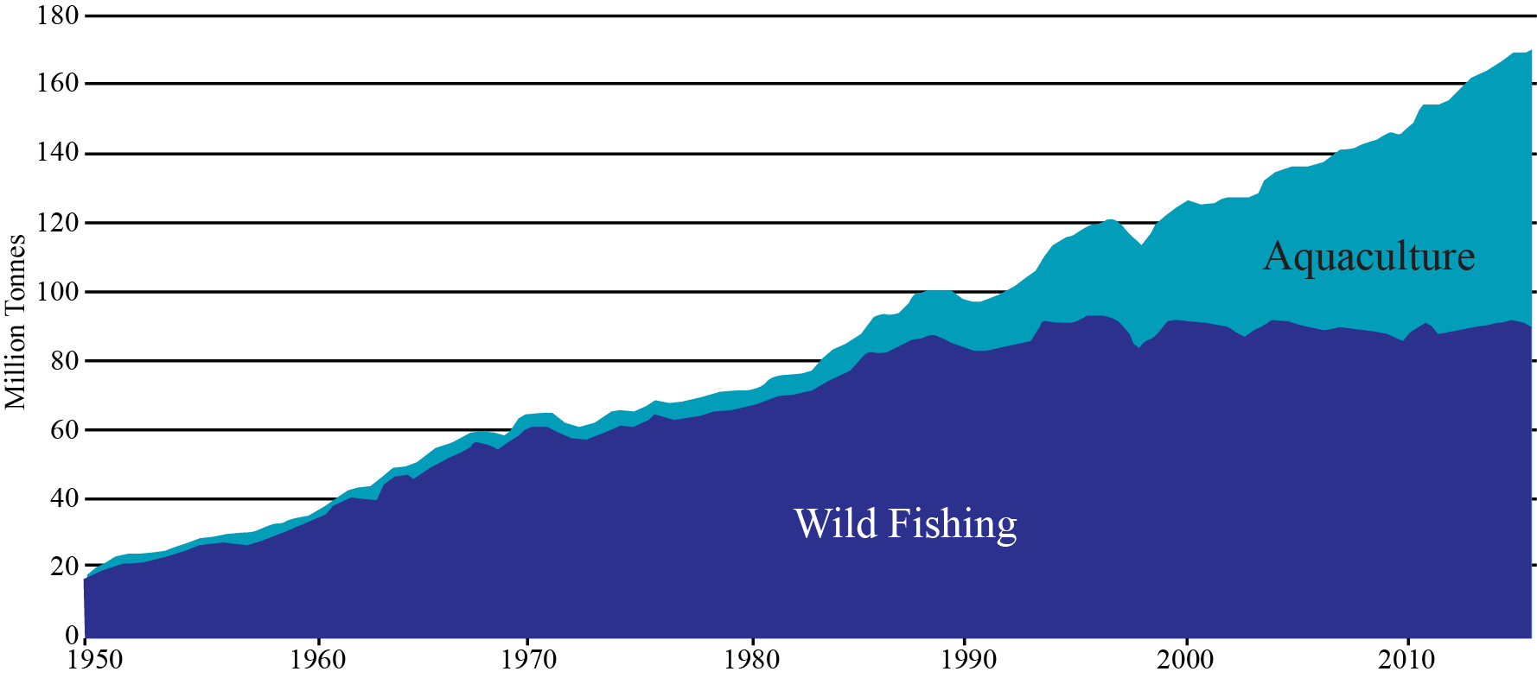
In British Columbia, aquaculture contributes significantly to B.C.'s economy. With its mild climate, good water quality and sheltered bays, the province's coastline is well suited to all forms of aquaculture. The total impact of finfish aquaculture is quite substantial with about $1.3 billion dollars injected into the provincial economy of a direct industry output of $750 million. In British Columbia, aquaculture is considered a mature industry with about 243 aquaculture establishments (2016 numbers) operating in the province. When considering competitive advantage, it is worth noting that when compared with Atlantic Canada the Pacific region produced more aquaculture product by tonne, with about half the facilities.
Table 5 shows aquaculture production in British Columbia for 2016. British Columbia leads Canadian production of salmon, clams and oysters. The maturity of the industry should be considered a competitive advantage when leveraging Canada’s free trade agreements such as the CPTPP and the new CAUSMA.
Table 5 Aquaculture Production in British Columbia for 2016
 | Volume (metric tonnes) | Value ($’000’s)
Salmon | 123,522 | 1,022,127
Clams | 1,962 | 7,076
Oysters | 13,824 | 39,693

As of 2017 there were 48 finfish licenses representing about 41% of all licenses issued in BC. The Island also produces over half of the shellfish farmed in the Province. The average value of shellfish and finfish on Vancouver Island from 2011-2016 was approximately $20M and $500M respectively.
Vancouver Island has become a center of influence and expertise in the areas of:
- Aquaculture services,
- Product research, design and development
- Integration/incorporation of advanced technologies
At the same time, business on Vancouver Island is sensitive to the misperception of diminishing returns, (automatically goods/people/services being transported on and off an island represent diminishing margins). This sensitivity has resulted in an emphasis on maximizing an integrated value chain, where suppliers deliver solutions that are mutually value-added versus a conventional supplier/user/customer relationship. For example, the work being led by North Island College under its 10-year applied research program in Sustainable Aquaculture represents a unique opportunity to capitalize on the synergies between aquaculture sectors (maximizing the value chain) whilst mitigating inherent (real and perceived) challenges of operating on an island. The Sustainable Aquaculture Research Program was initiated in 2013.

Finfish Aquaculture
In terms of finfish aquaculture, members of the BC Salmon Farmers Association produce approximately 76,000 tonnes of salmon annually - growing 58% of all salmon raised in Canada and accounting for 60% of the total landed value of seafood in British Columbia.
Farm-raised salmon is B.C.’s highest valued seafood product, and the province’s second most valuable agricultural crop. With approximately 70% of the annual harvest exported, farm-raised salmon is B.C.’s top agricultural export, going to 12 countries around the world - with 85% of exports destined for the United States, and the emerging Asian market accounting for about 15% of all exports.
Almost 80% of finfish farm sites (95) have Department of Fisheries and Oceans licenses with an expiry date of 2022 with the exception of those in the Discovery area which are on an annual licensing regime. Recent announcements by the Province and the Federal Government extended operations of some companies in the Broughton Archipelago to 2023. These companies also agreed to reduce the number of farms.

Shellfish Aquaculture
Canada’s total shellfish production in 2016 was just over 40,000 metric tonnes with a value of almost $90 million. By volume, mussels and oysters are the primary shellfish species cultured in Canada: in 2016, mussels accounted for 6% of the total national shellfish production while oysters accounted for an additional 35%. Canada ranks 12th globally in the production of both mussels and oysters. In global terms, British Columbia’s contribution to the production of farmed shellfish is small. British Columbia ranks as the 12th largest producer of Pacific Oysters, but only produces 0.12% of the value. Virtually the entire commercial harvest of British Columbia oysters is farmed and the commercial harvest of clams is steadily rising. While production values increase, shellfish farming has not come anywhere near reaching its potential as a key economic driver for coastal communities in British Columbia. There is room to grow!
For shellfish it should be noted that this is an export industry. More than 85% of Canadian aquaculture production is exported; the US is the largest export market for farmed shellfish. British Columbia farms 60% of the oysters produced in Canada and is Canada’s largest producer of farmed clams.

Aquatic plants
Today, the global seaweed harvest had an estimated value of US$6.4 billion a year, and commercial production more than doubled over the previous decade. Today seaweed is used in everything from ice cream to cosmetics to animal feed.
VI has thousands of kilometers of coastline, one of the richest areas in terms of seaweed diversity (over 600 Seaweed species in VI waters), in all of the temperate regions of the world.
World-class, compelling, Island-based research is underway, exploring the viability of growing kelp alongside fish farms, where excess nutrients from a fish farm act as a fertilizer for kelp, supercharging the plant’s growth. Kelp could provide additional revenue, while absorbing much of a farm’s waste, not to mention absorbing planet-warming carbon dioxide.
Companies exploiting the Korean aquatic-plants market are suitable targets for foreign direct investment and represent tremendous potential to bring a global industry to Vancouver Island. In 2015 the total aquaculture production in Korea was about 1.6 million tonnes with the farm gate value of USD 2.16 billion. Seaweed farming production was 1.2 million tonnes in 2015, accounting for 71 percent of the total aquaculture production by quantity and 20 percent in value. That equates to greater than half a billion $US. While Korea has about 2,413 kilometre of coastline upon which to exploit aquatic plants, there is limited room for increased production. The coast of Vancouver Island and adjacent islands is ten times longer and plays host to about 630 species of sea weed.
There are small operations currently harvesting seaweed on Vancouver Island including Canadian Kelp from Bamfield which produces food products and SeaFora from Sooke on the South Island which produces skin care products.

Vancouver Island Competitive Advantage
Vancouver Island offers unique attributes that should be considered global competitive advantages both in terms of geography and the level of maturity, with well-proven infrastructure and workforce. When considering the total available coastline, there exists excess production capacity throughout Vancouver Island. There is a unique oceanic environment with no major river system bringing heavy sediment loads to the coast. Waters are relatively unaffected by agriculture run off or other deleterious effects from poor land use practice experienced in other justifications around the world. For example, anecdotally it has been said that aquatic plant production is very limited along the coast of China due to pollution.
Being an Island, where communities have long exhibited strong cooperation in support of economic development, there is a strong sense of connection and shared values, driving efficiencies and resulting in more integrated value chains. This alignment of incentives maximizes the multiplier effect. As an example, studies into polyculture systems indicate that production of finfish, when grown within a multi-species system including shellfish, seaweed and other benthic organisms, can serve to significantly mitigate the presence of disease and the negative impacts on the surrounding aquatic environment.
Vancouver Island also offers a strategic location as the North American gateway to Asia, with container traffic and international airlines moving via high-grade routes to Asia/Pacific countries. This represents an opportunity to rapidly get product into the hands of the consumer. This is especially true for the trade imbalance between China and North America where there is excess capacity on ships and cargo air craft returning from North America to Asia. The major airports on Vancouver Island have the capacity to expand with a wealth of under-utilized industrial land adjacent to these aerodromes.
For certain sea food species such as sea urchins, sea cumber and geoduck there are well-established markets in Asia. British Columbia suppliers have a deep understanding of this market including processing methods, packaging, time sensitivity (seasonal markets) and other factors that would contributing to greater sales volumes at better margins.

Workforce Considerations
For its relatively small geographic extent, aquaculture production on Vancouver Island exhibits a level of maturity unmatched in other industrial sectors. Four of the world’s major sea food production companies including the world’s biggest, Marine Harvest, have offices and production facilities on the Island. This contributes to the Vancouver Island brand as having high quality and abundant aquaculture production. Along with these well established companies operating here, the type of workforce that these businesses attract results in a wealth of highly-skilled workers. It is quite likely that, as in other sectors, once an individual is employed on the Island they are more likely to remain here through their working life.
Table 6 shows fishing related employment by industry for the years 2014 to 2016. While overall fishing-related employment in BC has declined by ~ 5.6%, employment in aquaculture over the same period has grown by ~14.5%. Overall, farming salmon in B.C. generates approximately $1.5 billion per year to the province’s economy, and accounts for about 6,600 jobs - typically located in rural coastal areas and paying approximately 30% more than the median employment income in BC.
Table 6 Fishing related employment in British Columbia by industry, 2014-2016
Primary Sector (Harvesting) |  |  | Seafood Product Preparation and Packaging (Processing) |  |  | Aquaculture |  |  | Total Employment (Primary Harvesting, Processing and Aquaculture)
2014 | 2015 | 2016 | 2014 | 2015 | 2016 | 2014 | 2015 | 2016 | 2014 | 2015 | 2016
6,008 | 5,308 | 5,206 | 2,519 | 2,392 | 2,645 | 1,450 | 1,480 | 1,565 | 9,977 | 9,112 | 9,416

There exists an excellent opportunity to build capacity in coastal communities as the aquaculture sector grows. Aquaculture can be identified as a pathway to First Nations employment. Particularly as there is a changing demographic in First Nations communities biasing towards youth. Furthermore, aquaculture demands a broad spectrum of skills. Future employment opportunities include higher skill sets such as engineering and data monitoring systems, with digital-mobility mitigating some of the recruiting challenges faced by many coastal communities.
Aquaculture represents a partnering opportunity for First Nations with international or domestic primary producers. This is beneficial not only in keeping community members gainfully employed in full time and long-term jobs, but as equity holders, First Nations business groups will join forces with well-established global companies, building and maintaining business-expertise that can be transferred to many other of their nation’s business interests. As equity holders in successful business, wealth is generated to support other priorities in coastal communities. Perhaps an underestimated advantage in such a partnership is the wisdom that a First Nation carries through its ancestry. With a traditional background and centuries cultivating marine resources, British Columbians can bring new and excellent innovation ideas to the world through their international partnerships. It should be noted that aquaculture is a highly labour intensive industry due to the level of oversight required. Processing facilities also require relatively large workforces.

Market Landscape (Aquaculture Technologies)
Given the production volumes of aquaculture on Vancouver Island there is strong demand for a service industry that can partner in supporting production capacity, and systems design. British Columbia and Vancouver Island in particular has a strong culture of innovation that is very well supported by government research incentives. Programs such as the Scientific Research and Engineering Design as well as the Industrial Research Assistance Program of the National Research Council offer significant monitory contributions to industry. Vancouver Island has several universities and colleges that attract both domestic and foreign students that support a growing technology sector.
There are numerous Island-based technology companies exporting goods and services to South America and Europe. One such company, Poseidon Ocean Systems of Campbell River, provides a full service offering to the global aquaculture industry. The innovation arm of this company is capable of tailoring systems designed to accommodate unique marine settings. As with many other industries, new product research and development is initiated because of a need to deliver improved operational efficiencies or in response to perceived gap in technology offerings. Such is the case with an Island-based aquaculture company, Agrimarine Ltd. Many aquaculture stakeholders predict the future of finfish farming on the open ocean lies with closed-containment systems. Similarly, management systems for ocean pen infrastructure have improved significantly. Against this backdrop, Agrimarine Ltd. has researched and designed a close containment system and has now successfully exported two such systems into Norway.

Value Chain
It is worth considering the distribution of value in billions of dollars across the aquaculture value chain. Figure 5 shows an estimate by OECD indicated the total value is approximately $525 billion. What is perhaps more compelling is that the value of aquaculture is rapidly approaching the value of capture fishing.
Figure 5 Value chain with dollar values for 2006.
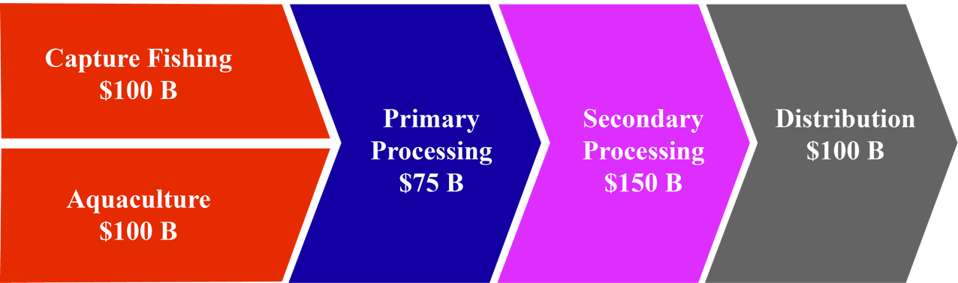
In a recent report on the state of capture fisheries and aquaculture the FAO reported that in 2013 wild caught fish for human consumption equaled that of aquaculture. About 13% of fish processed today is not for human consumption. Furthermore the FAO projected that by 2020 aquaculture for human consumption will surpass the total fish captured in wild fisheries.
Figure 6 Global capture fisheries and aquaculture production, 1990-2030
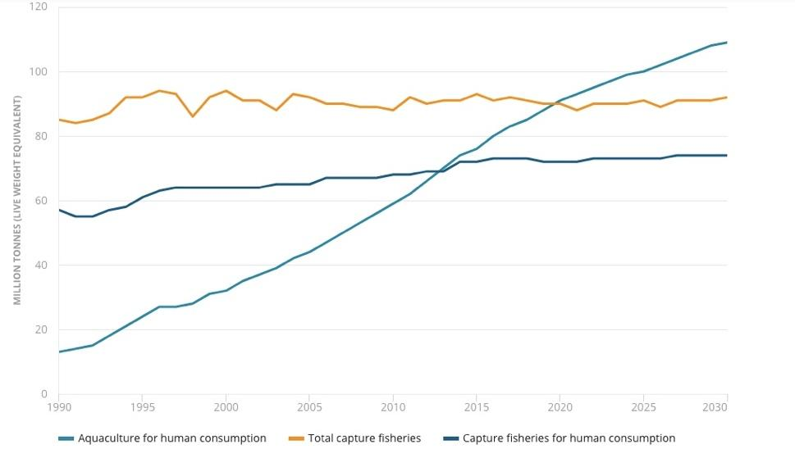

The aquaculture value chain is that of input supply through to the retail delivery of product. Figure 7 shows the aquaculture value chain for the purpose of this Business case. From the Vancouver Island perspective there are key elements that are well suited to its geography, experience and available skill sets. Given our unpolluted coastal water and ready supply of fresh stream water, investment in brood stock and hatcheries will bring returns not only to meet the demands of domestic supply but as a high potential export commodity.
Figure 7 Detailed view of the aquaculture value chain with stars indicating FDI opportunities.
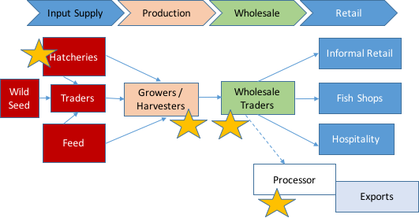

Financial Overview
The financial implications of an aquaculture operation are dramatically different depending on the operations envisioned. For example:
- Initially acquisition of licensing and regulatory approvals are required.
- Most aquaculture operations require an element of land-based facilities for logistics and support services, as such there will be a need to secure land access.
- Processing facilities and cold storage are also required unless third-party processing is contemplated.
- Seagoing equipment must be purchased and assembled.
The absolute dollar value investment is not a practical starting point for discussion of a financial overview. Commentary below on financial elements will help put balance sheet and income statements in a Vancouver Island context.

Capital Intensity
In the aquaculture market today there is an ongoing conversation about methods used to cultivate fish. There is significant public discussion on the use of open net-pen systems versus closed-containment systems in the ocean, versus land-based closed-containment systems. In British Columbia the rule of thumb for a comparison is that for each open pen the capital cost of a marine closed containment system is ten times more and the capital outlay for a land-based recirculating aquaculture system (RAS) is 100 times more. This is somewhat reflective of the land and energy costs involved.
While the cost of recirculating aquaculture systems has come down, in a 2010 study the Department of Fisheries and Oceans calculated the capital cost of open-net aquaculture at $5 million, with a 52% return on investment in the third year, compared with $22.6 million for land-based aquaculture, with a return on investment of 4%.
The investment required for sea weed farming is significantly less. As one individual said “all you need is a rock and a rope”. While the capital for marine-side operation may be substantially less for growing sea weed, specialized harvesting equipment, for example, is required which can cost in excess of $200,000 per harvester. In general, the size of the investment is quite variable depending on scale, type of seaweed, proposed product, and whether you have seed production or processing.

Financing Costs
Financing costs would be commensurate with those from a normal agricultural operation. There would however be a risk premium for a marine setting. This premium should be less than one percent.
Aquaculture is similar to agricultural lending in that more stable market demand, will result in greater price certainty and therefore predictability of cash flow available to service debt. Specialized equipment and buildings, as well water-based assets, may impact the conventional financing capacities of some commercial banks.

Revenue Expectations
There are major global aquaculture players operating in BC and Canada. This is an estimate of key financial indicators from their BC or Canadian operations. These are approximations based on their Q3 performance from published financial information. Grieg Seafoods and Marine Harvest are both Norwegian companies. Another global aquaculture company, Cermaq, operating in BC, is headquartered in Norway but is owned by Mitsubishi Corp. of Japan.
Table 7 Summary of estimated financial indicators of two global companies operating in British Columbia
Company | Grieg Seafoods | Marine Harvest
Revenues CDN$(000’s) | $25,920
EBIT | $1,920 | $ 19,760
Harvest (tonnes) | 2,642 | 12,405
EBIT/Kg | $ 0.73 | $1.60

Expenditures
In Canada there is a move towards implementing a carbon tax. In British Columbia a carbon tax is already levied on industry at a rate of $35 per tonne of carbon dioxide equivalent emissions. The tax rate will increase each year by $5 per ton until it reaches $50 per tonne in 2021. If carbon footprint is a proxy for operating costs in the future it is worth noting that currently, the carbon footprint of raising fish in oceans is far lower than other farmed produce. For salmon it is 2.9 per kilogram, while chicken is 3.4, pork is 5.9, and beef is 30. There is another proxy for cost that provides a different view. Feed is one of the biggest costs for an aquaculture operation representing approximately 50-55%. The feed conversion ratio (FCR) the ratio of feed to desired output. For salmonids the FCR is 1.2 – 1.2 while for pork it is 2.5-3.0.
When comparing operating costs for marine open or closed systems it is clear that closed containment systems are subject to less risk to their biological assets from surrounding environmental elements. For example, losses due to oxygen depletion, algae and seals take a toll on stock. One local expert suggested that a closed containment system is akin to a stock management system as opposed to an environmental management system. Aquaculture is a labour intensive industry with a mix of skills required. Minimum wage labour in British Columbia is $12.65 per hour. Average wage of a Marine Technician in Canada is $32.50 per hour and a Mechanical Engineer would make about $70,000 per annum.

Why Kelp? http://canadiankelp.com/why-kelp/
Seaweeds as a source of nutritionally beneficial compounds – A review, (2008), Chandini, Shantha & Ponesakki, Ganesan & P V, Suresh & Bhaskar, N. Journal of Food Science and Technology -Mysore-. 45. 1-13.
The State of World Fisheries and Aquaculture, 2018, Food and Agriculture Organization of the United Nations. http://www.fao.org/3/i9540en/I9540EN.pdf
Canada’s Fisheries Fasts Facts 2017, http://www.dfo-mpo.gc.ca/stats/facts-Info-17-eng.htm
State of the Island Economic Report, http://viea.ca/economic-resources/state-of-the-island-report-download/
Fisheries and Aquaculture Country Profiles, The Republic of South Korea, 2017, Food and Agriculture Organization of the United Nations, http://www.fao.org/fishery/facp/KOR/en
http://canadiankelp.com/ , https://seafloraskincare.com/
The State of the World Fisheries and Aquaculture, 2018, Food and Agriculture Organization of the United Nations, http://www.fao.org/state-of-fisheries-aquaculture/en/
Canadian-owned land-based fish farm goes bankrupt, November 2018 SeaWestNews https://www.seawestnews.com/canadian-owned-land-based-fish-farm-goes-bankrupt/
Feed Conversion Ratio for Farmed Fish, https://www.aqua-techna.com/en/productivity/experts/feed-conversion-ratio-farmed-fish

